|  |
| --- |
| **Name:** |

**ECE 2074 Lab 00 – Fall 2019**

**Submit this completed check list as a pdf to Assignment 0!**

**NOTE: Your name is required! No Name = 0, no credit!**

Place "**x"** in the **[ ]** bracket if item has been checked and is **complete**.

Place **"-", "I", or the quantity** in the **[ ]** bracket if item has been checked but is **incomplete**.

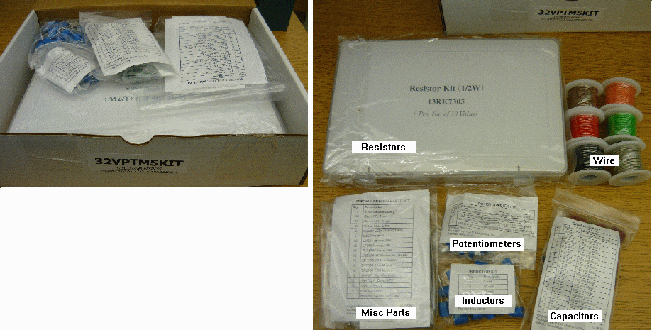

**Resistor Kit (plastic box)** - see the color code chart in Miscellaneous parts

**[ ] 5 of each carbon film resistor value** 1Ω, 1.2Ω, 1.5Ω, 1.8Ω, 2.2Ω, 2.7Ω, 3.3Ω, 3.9Ω 4.7Ω, 5.6Ω, 6.8Ω, 8.2Ω

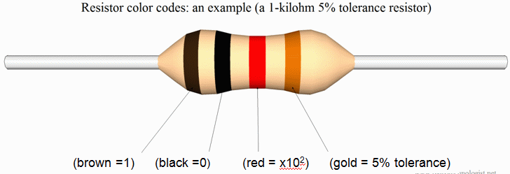

10Ω, 12Ω, 15Ω, 18Ω, 22Ω, 27Ω, 33Ω, 39Ω, 47Ω, 56Ω, 68Ω, 82Ω

100Ω, 120Ω, 150Ω, 180Ω, 220Ω, 270Ω, 330Ω, 390Ω, 470Ω, 560Ω, 680Ω, 820Ω

1kΩ, 1.2kΩ, 1.5kΩ, 1.8kΩ, 2.2kΩ, 2.7kΩ, 3.3kΩ, 3.9kΩ, 4.7kΩ, 5.6kΩ, 6.8kΩ, 8.2kΩ

10kΩ, 12kΩ, 15kΩ, 18kΩ, 22kΩ, 27kΩ, 33kΩ, 39kΩ, 47kΩ, 56kΩ, 68kΩ, 82kΩ

100kΩ, 120kΩ, 150kΩ, 180kΩ, 220kΩ, 270kΩ, 330kΩ, 390kΩ, 470kΩ, 56k0Ω, 680kΩ, 820kΩ

  1MΩ

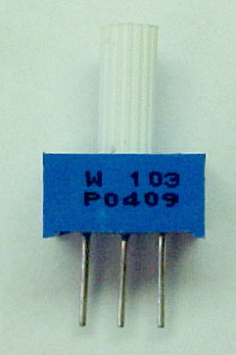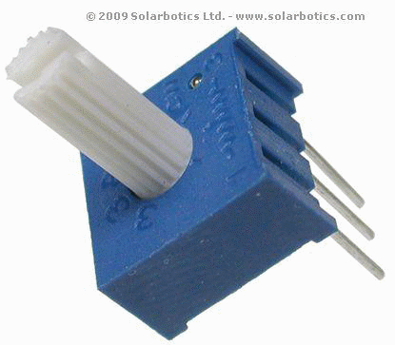

**Potentiometer (bag)** The 3 digit code gives the value.

**2 of each value**  
[ ] 100Ω (marked 101), [ ] 1.0kΩ (marked 102), [ ] 10kΩ (marked 103)

**Inductor Kit (bag)** The value is marked on the top

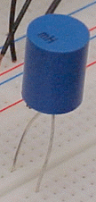

**2 of each value**  
  
[ ] 1mH (marked 1 mH), [ ] 100mH (marked 100 mH)

Place "**x"** in the **[ ]** bracket if item has been checked and is **complete**.

Place **"-", "I", or the quantity** in the **[ ]** bracket if item has been checked but is **incomplete**.

**Capacitor Kit (bag)**  see <http://www.wikihow.com/Read-a-Capacitor>

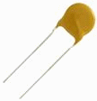

**Ceramic Disk or Monolithic Capacitor (5 of each value)**

**[ ] 100pF (marked 101), [ ] 0.1μF**

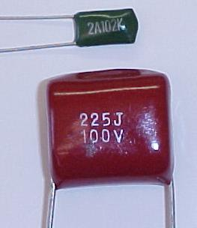

**Mylar Film Capacitor (5 of each value)   
 [ ] 0.001μF (marked 102), [ ] 0.0022μF (marked 222), [ ] 0.0047μF (marked 472)  
  
 [ ] 0.01μF (marked 103), [ ] 0.022μF (marked 223), [ ] 0.047μF (marked 473)  
  
 [ ] 0.1μF (marked 104), [ ] 0.22μF (marked 224), [ ] 0.47μF (marked 474)**

**Non-Polar Electrolytic (5 of each value)  
 [ ] 1.0μF (marked 105), [ ] 2.2μF (marked 225), [ ] 4.7μF (marked 475)**

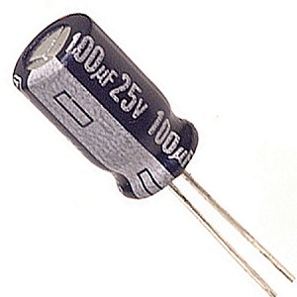

**Electrolytic Capacitor (5 of each value)  
  
 [ ] 10μF (marked 10μF), [ ] 47μF (marked 47μF),   
  
 [ ] 100μF (marked 100μF)**

**Wire Kit (bag or loose in box)**

**[ ] (6 spools total) 25' spool each of Red, Black, and four other colors.**

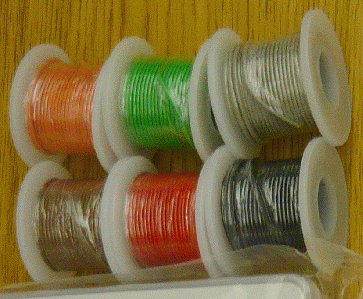

**Miscellaneous parts (bag or brown box)**

Place an "**x"** in the "**Check" column** if the item has been checked and is **complete**.   
Place a **"-"** (dash)**, an "I", or the quantity** in the "**Check" column** if the item has been checked but is **incomplete**.

|  |  |  |  |
| --- | --- | --- | --- |
| **Check** | **Qty** | **Part** | **Image** |
|  | **1** | **9 volt alkaline battery** |  |
|  | **5** | **Red LED** |  |
|  | **5** | **Green LED** |
|  | **5** | **Yellow LED** |
|  | **2** | **CDS003-7004 Photo cell** |  |
|  | **2** | **NJM4556A 8-pin, dual, high-current op amp** |  |
|  | **10** | **LF356N 8 pin op amp** |  |
|  | **5** | **LM311 8 pin comparator** |  |
|  | **5** | **TLC555C 8 pin timer** |  |
|  | **5** | **2N3904 NPN Transistor** |  |
|  | **5** | **2N3906 PNP Transistor** |  |
|  | **5** | **2N7000 N-MOSFET** |  |
|  | **5** | **TP0606 P-MOSFET** |  |
|  | **5** | **1N4001 Silicone rectifier diode** |  |
|  | **2** | **1N5226B 3.3V Zener Diode** |  |
|  | **2** | **1N5817 20V, 1A Schottky Diode** |  |
|  | **1** | **Resistor Color Code Card** |  |

**Submit this completed worksheet as a pdf to Assignment 0 before the deadline!**